**CMPE-277: Smartphone application Development**

**Assignment 4 – TH Sensor driver (Async Task)**

**Submitted to:** Prof. Chandrasekar Vuppalapati

**Submitted by:** Anvit Saxena (SJSU ID: 010953436)



In this assignment, we demonstrate the concept of Async Task. I have created an Android Application in which I have used Async Task to run tasks that take longer than five seconds in the UI context. In this application, we random sensor readings in the UI and update the readings in the ScrollView accordingly. Following are the steps along with screenshots that explains in detail:

**Step 1:** The application “AsyncTaskDemo” as shown below has one main activity with three fields and one user input field, to enter number of readings to generate random values of Temperature, Humidity and Activity.

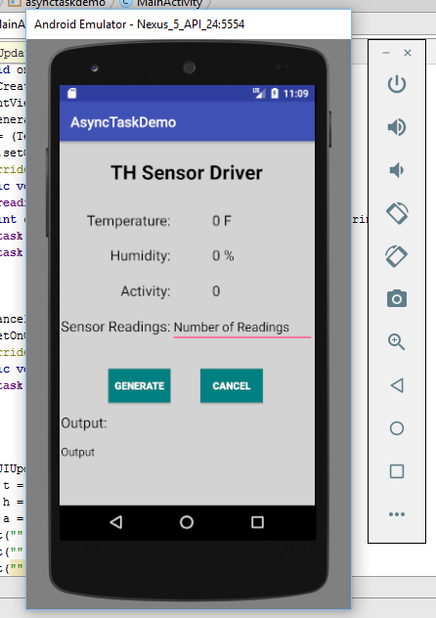

**Step 2:** We give the readings a number of 5 and then click on Generate button. After clicking this button, application will generate five output readings with random data populated in temperature, humidity and activity fields as shown below:

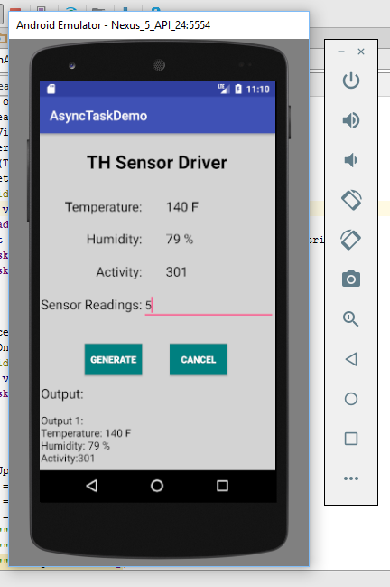

**Step 3:** Similarly, it will keep on generating 5 outputs with random readings data unless the count is reached.

